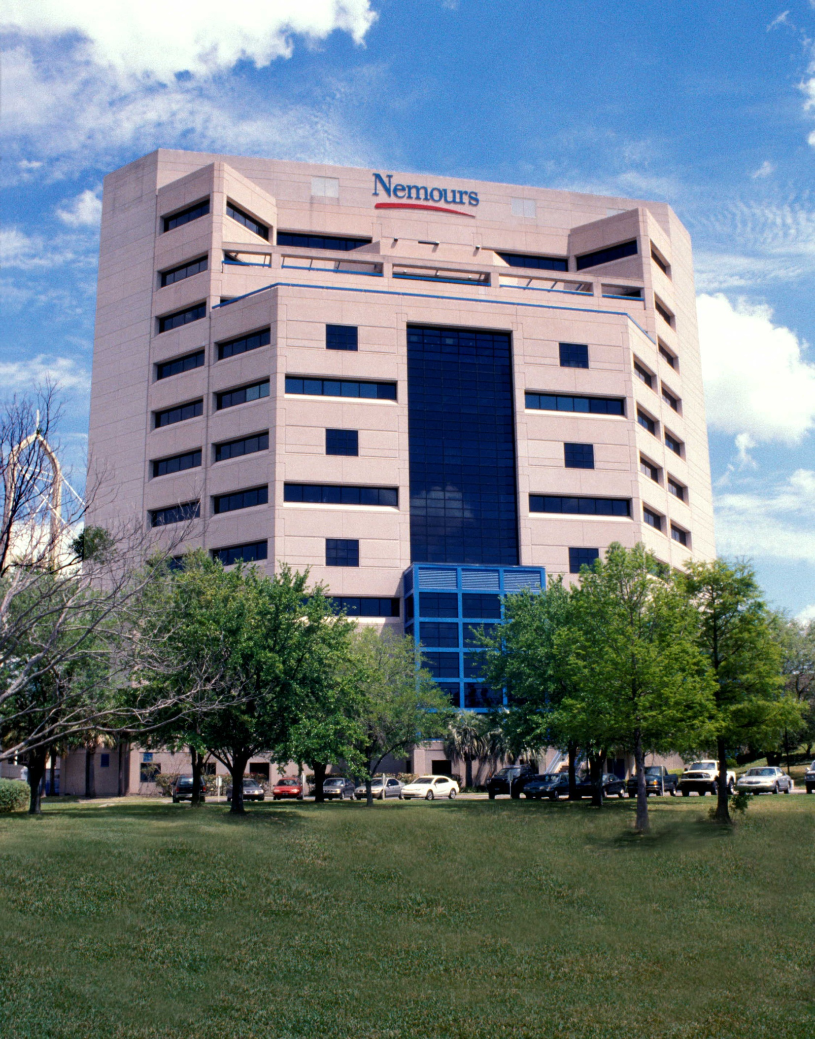

Nemours Children’s Specialty Care: Ophthalmology

Contact Information:
Referring Physician’s Line: (904) 697-3845
For Appointments: (904) 697-3705
Ophthalmology Clinic Fax: (904) 697-3463

Locations:
Downtown Jacksonville
807 Children’s Way
Jacksonville, FL 32207

Fleming Island
1747 Baptist Clay Drive, Suite 130
(US 17 and Village Square Parkway, in the Baptist Clay Medical Office Building)
Fleming Island, FL 32003

Doctors:
Merrill Stass-Isern, MD (division chief)
Lee Hunter, MD
Karen Alvarez, DO
Amanda Bourgeois, OD
John Erickson, OD, FAAO

